Task on Docker - 02

- Create a tomcat container on 8080 and deploy a sample application in tomcat.

First Login to our instance using SSH
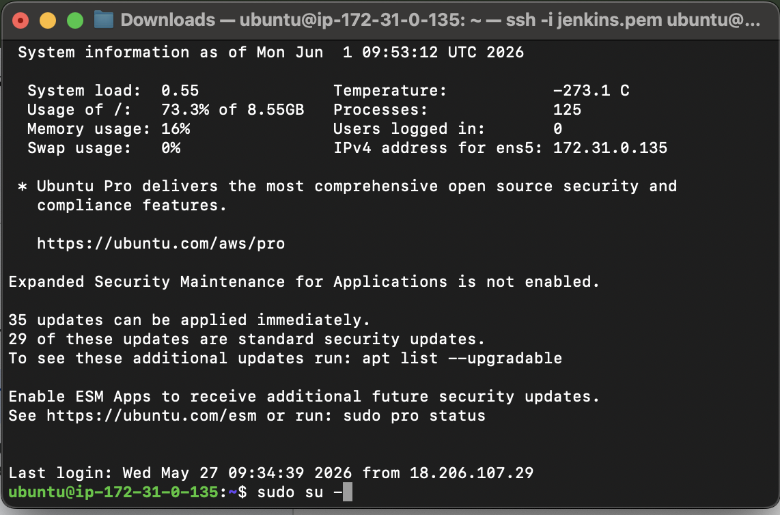
Switch To root user
check systemctl status docker
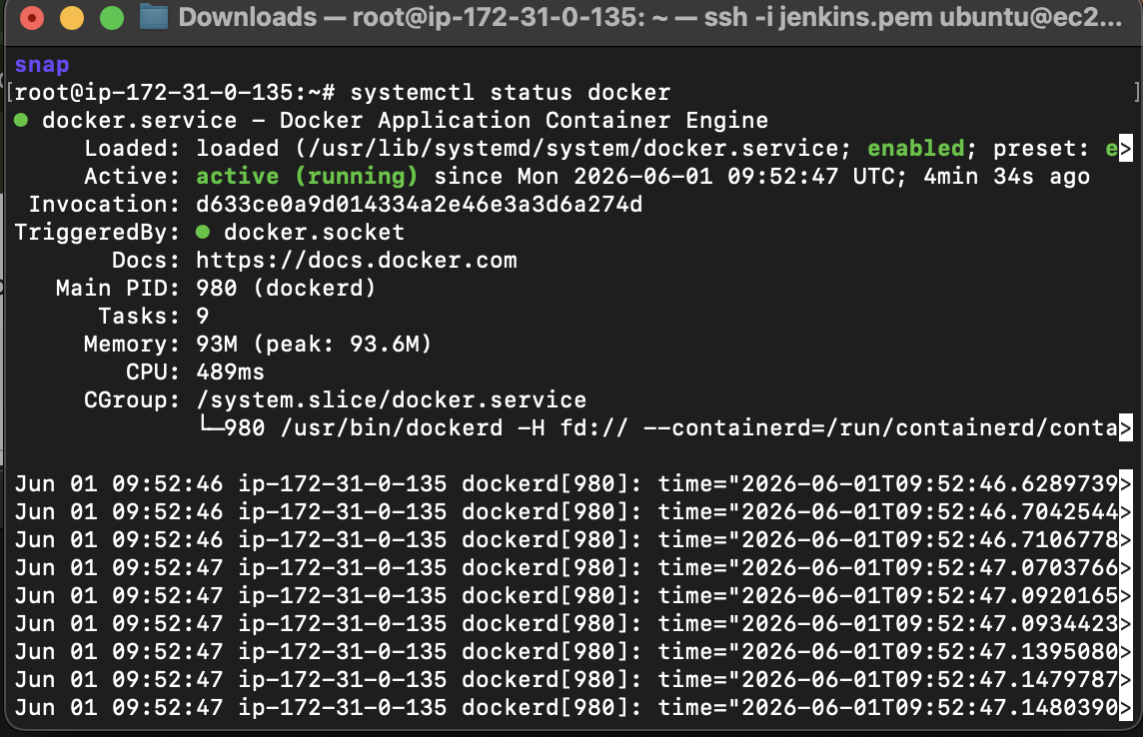
Docker is active
Now lets pull tomcat using docker pull tomcat:latest
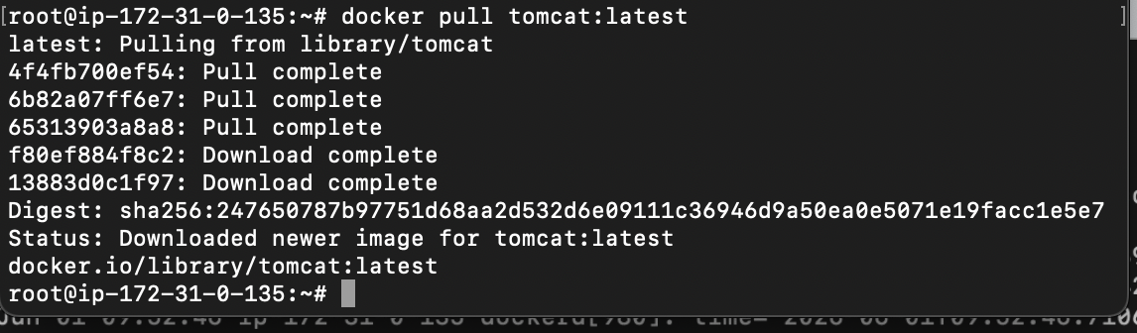
Docker images ⇒ we can see the images has successfully pulled
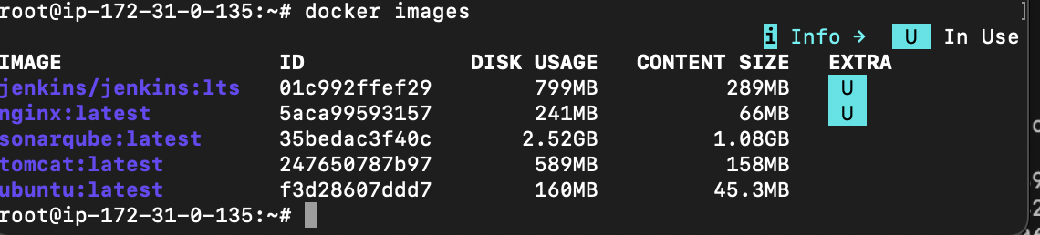

Lets run the image now by using command
docker run -itd -p 8080:8080 tomcat:latest

Now lets check using ipaddress:8080

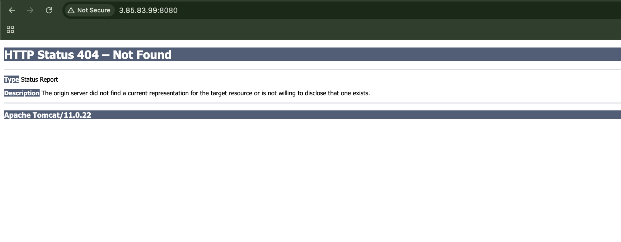
Our tomcat is running, now lets deploy a sample war file
So need to login
Using docker exec -it container_id /bin/bash
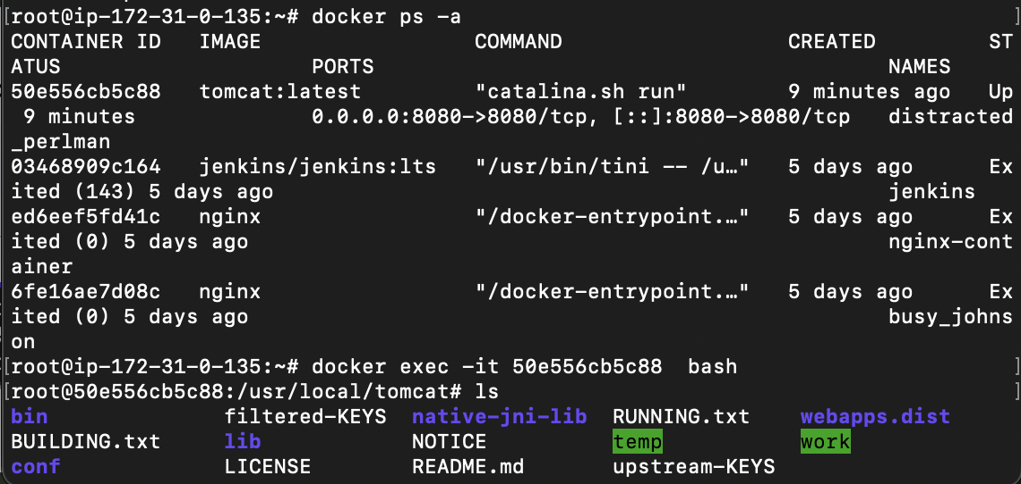
To deploy sample war file we need to update the packages and install wget for that we will use command
Apt update
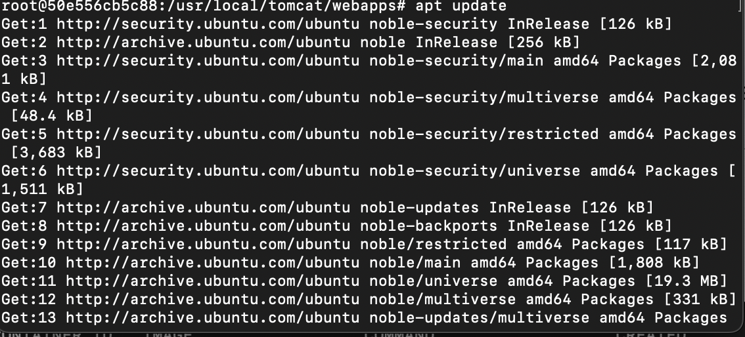
Apt-get install wget -y
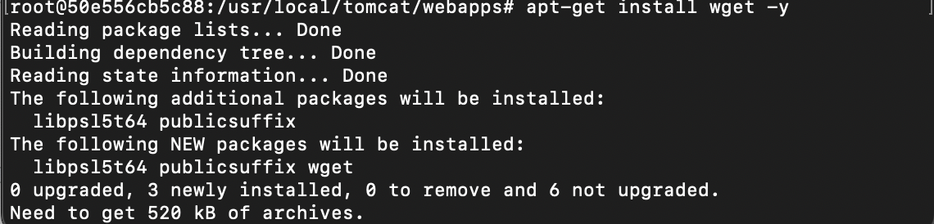
Wget weblink
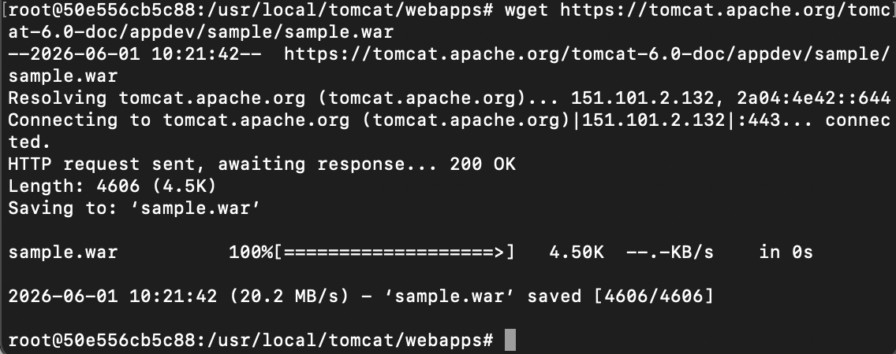
Sample.war has been deployed in webapps
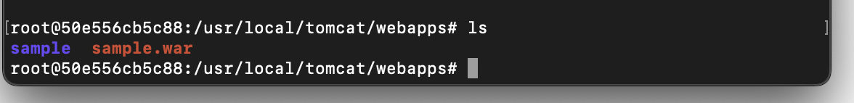
Now lets check in browser using ipaddress:8080/sample
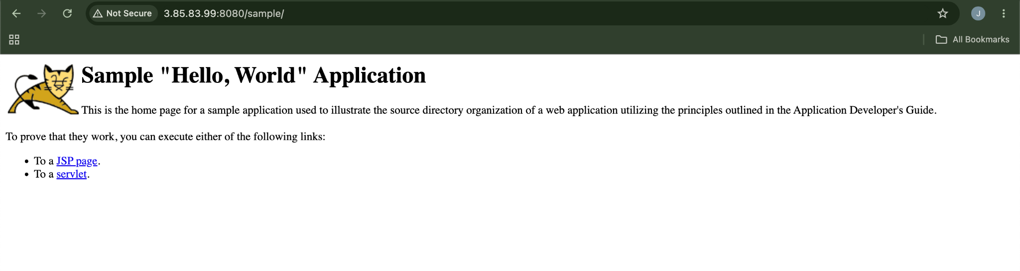

- Create volume and deploy a tomcat container on port 8081.
Lets create volume by using command
docker volume create deployment
And check if it has been created or not by using docker volume ls
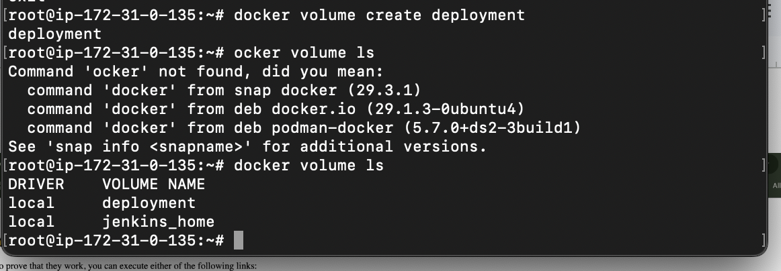
Now lets go to the folder
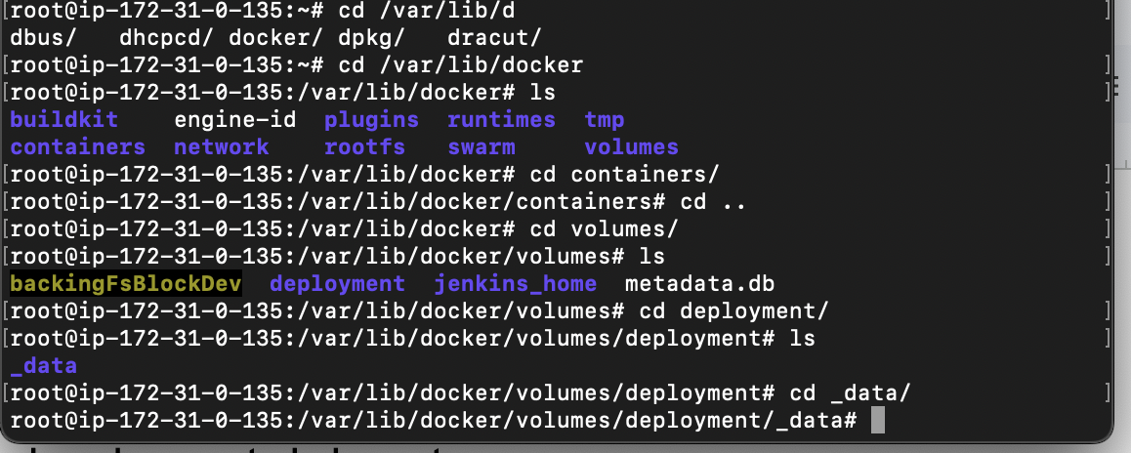
Now lets deploy a sample war file using wget
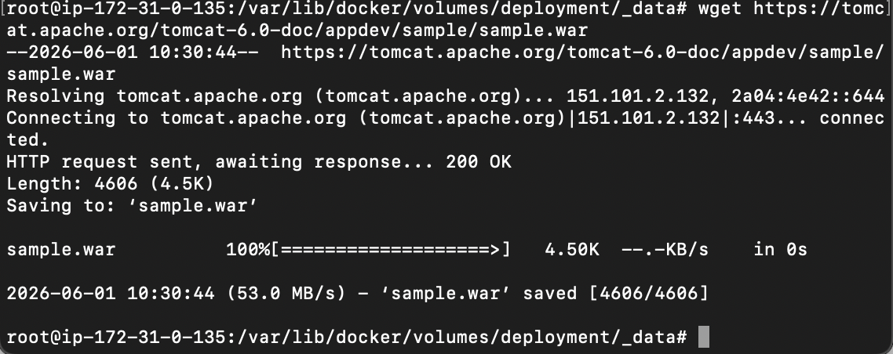
Now lets run the image using command
docker run -itd -p 8081:8080 -v /var/lib/docker/volumes/deployment/_data:/usr/local/tomcat/webapps tomcat:latest

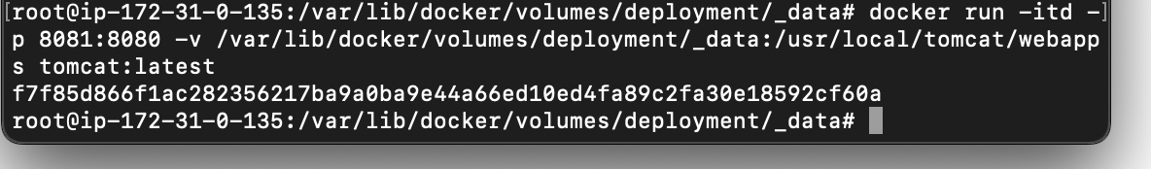
Lets check the url by using port 8081
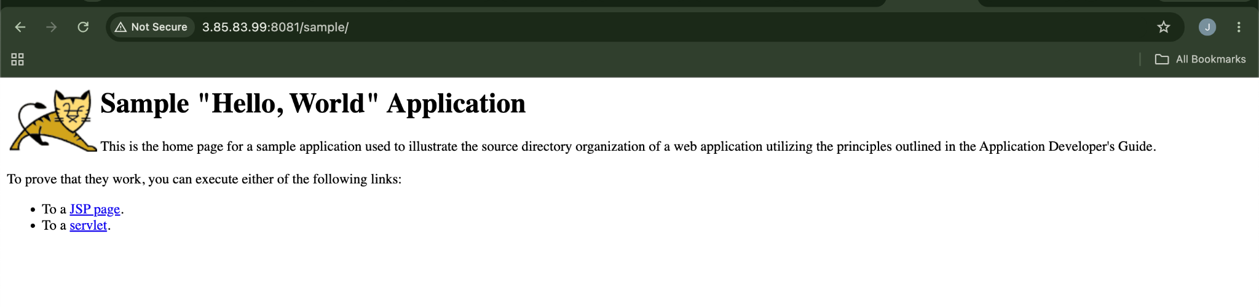
- Limit the nginx container to 500 MB.
By using command
Docker run -itd -p 80:80 –memory=500m nginx:latest ∫
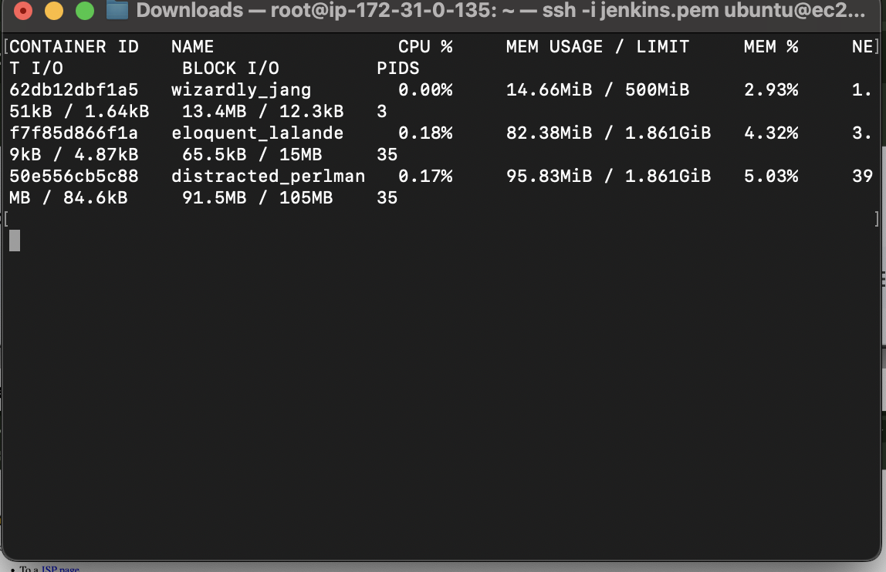
- Create a sample docker file using below instructions.
  - Base module as amazonlinux:latest
  - Maintainer you name
  - Install nginx
  - COPY one index.html file to image
  - Expose on port 80
  - Command to start the nginx container
Lets create an Index.html file first
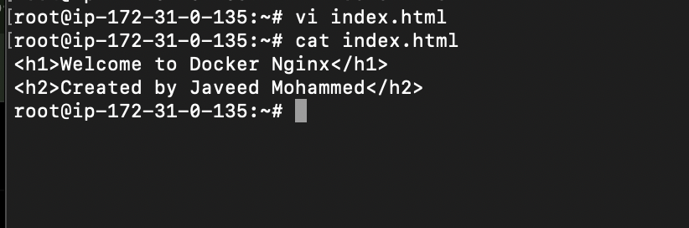
Now lets create a docker file
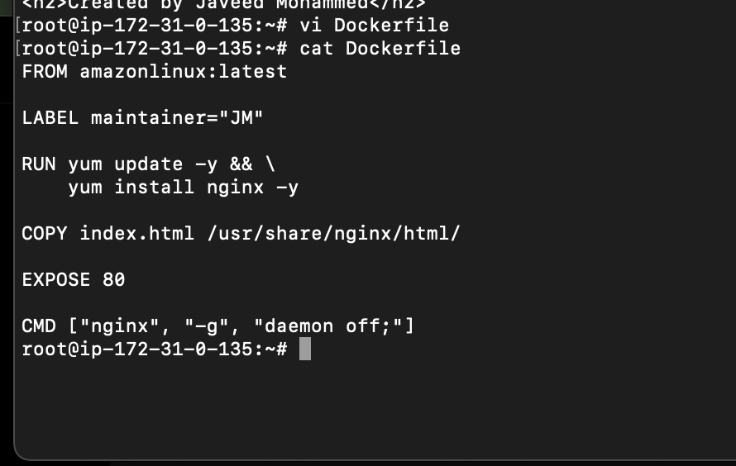
Now lets build
docker build -t javed:v1 .
Step 1 and 2
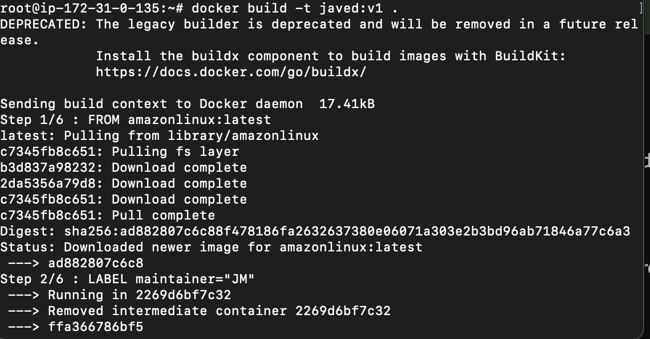
Step -3
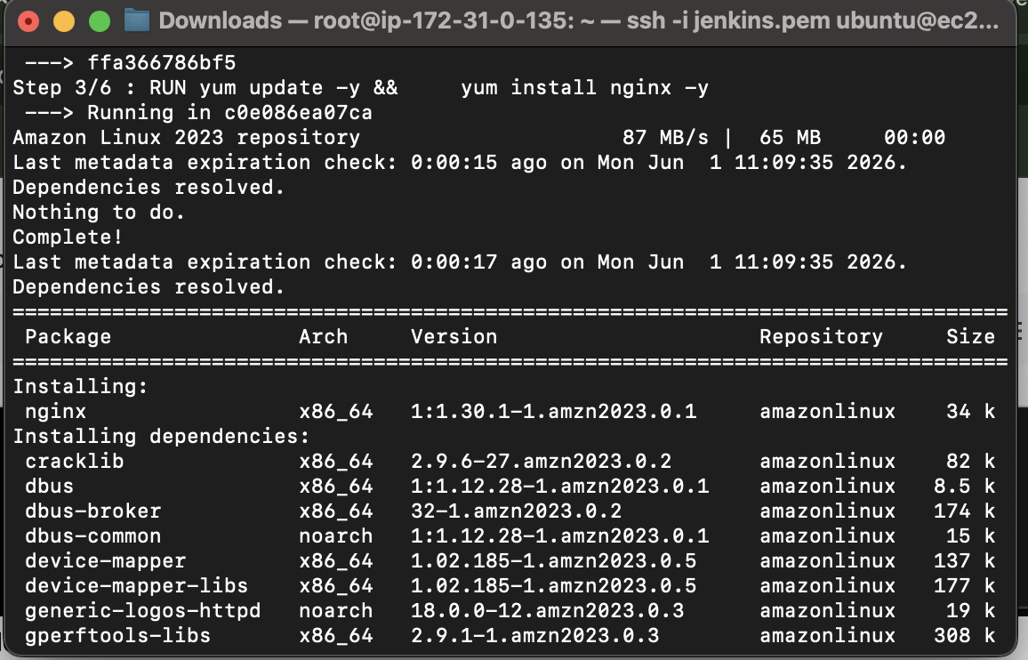
Step 4,5,6
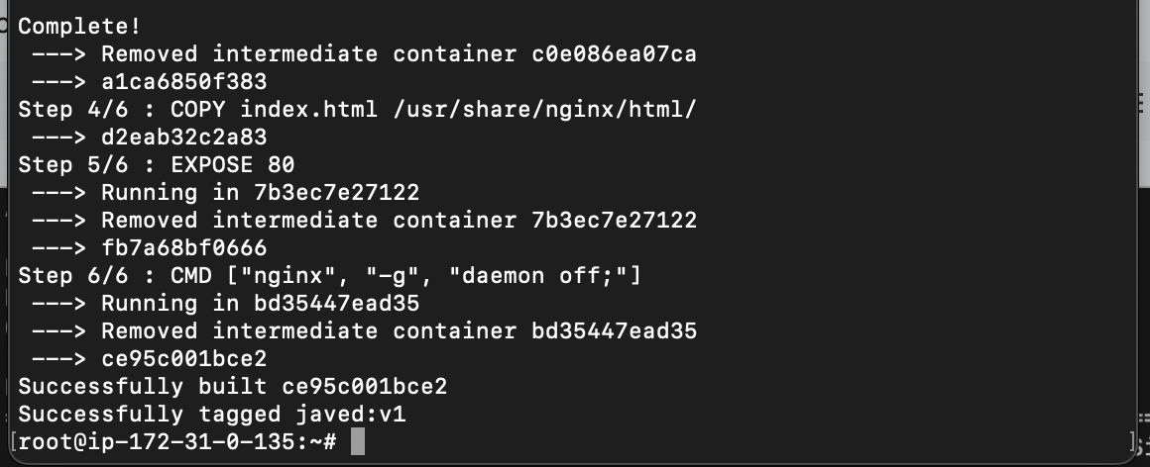
Now Lets run
docker run -d \
--name nginx \
-p 8082:80 \
javed:v1
Docker images
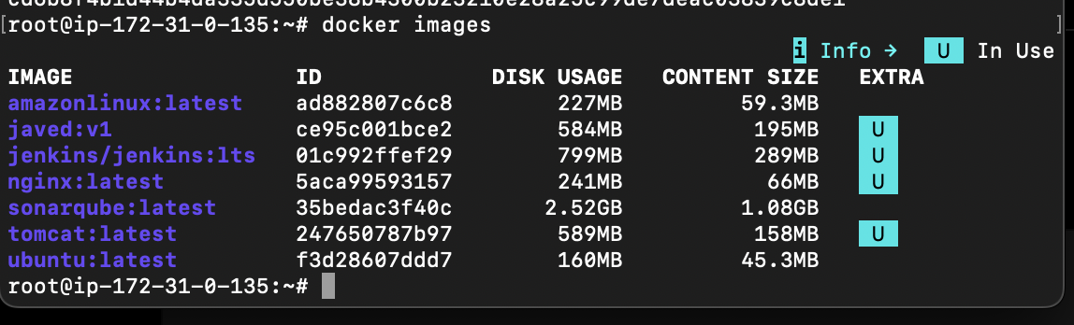

Lets check in browser
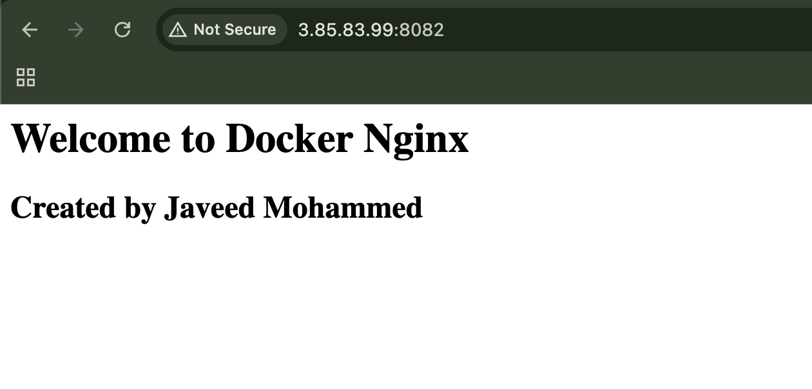

- Push image to Docker hub
Create a repo in Docker hub
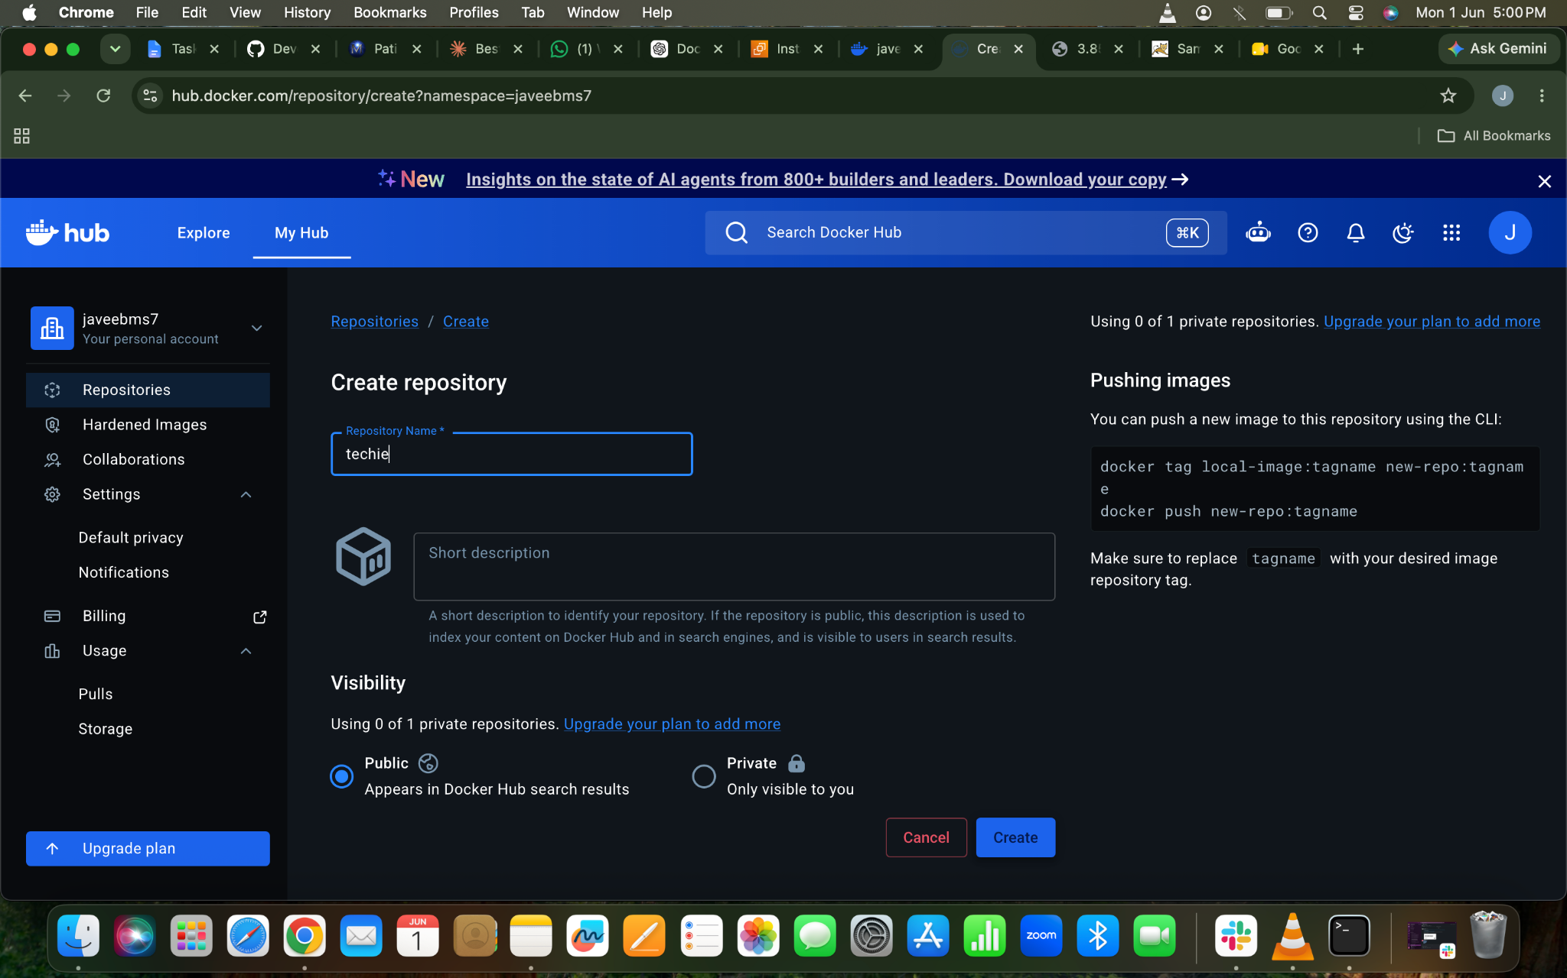
Docker login
docker login ⇒ u will get ca ode need to enter in the browser u will find the link in cli itself and the code too
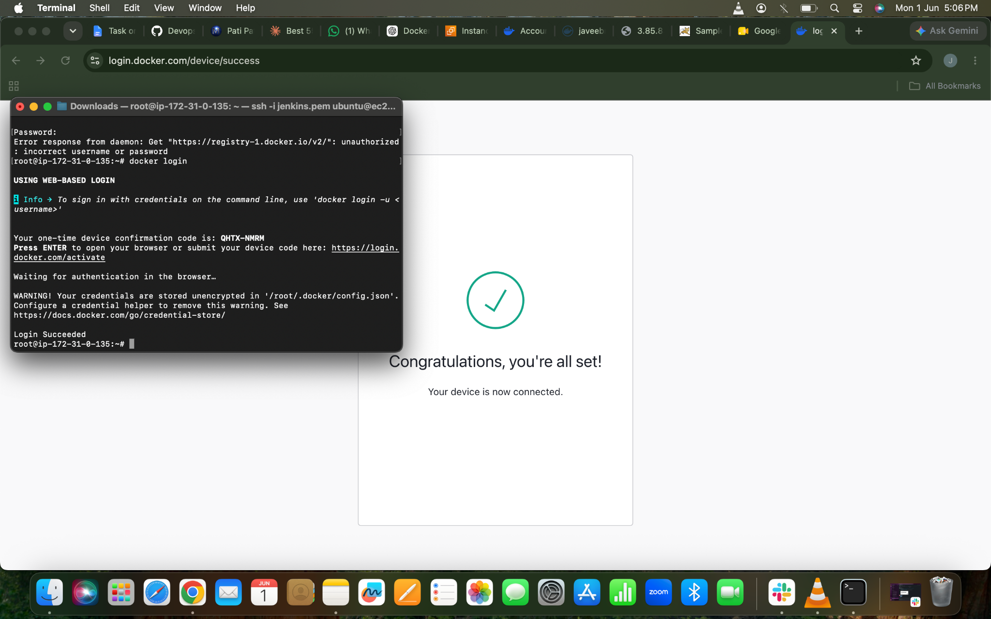
Now lets rename our image name by using command
docker tag javed:v1 javeebms/techie:v1 and to push the image to repository use the command
docker push javeebms7/techie:v1
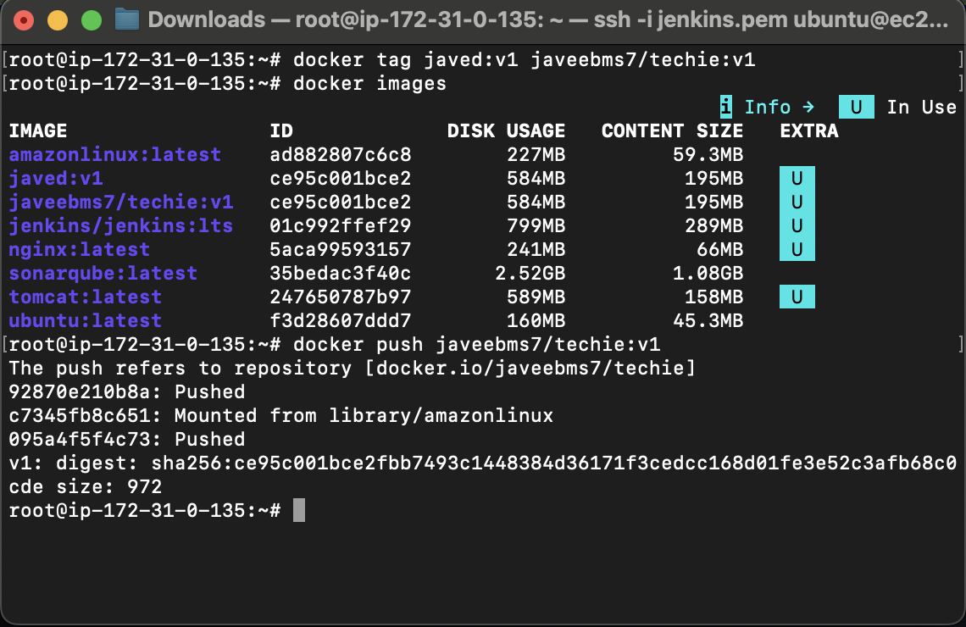
Now lets check in the Docker Hub
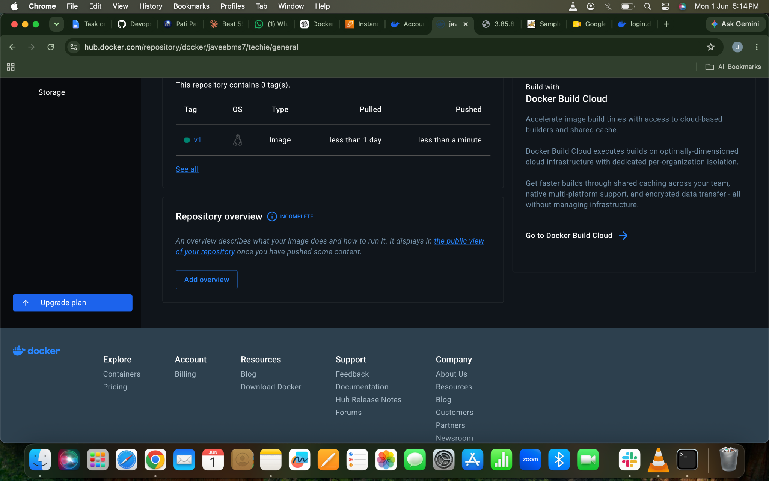
- push image to AWS ECR
Lets create a repo in ECR
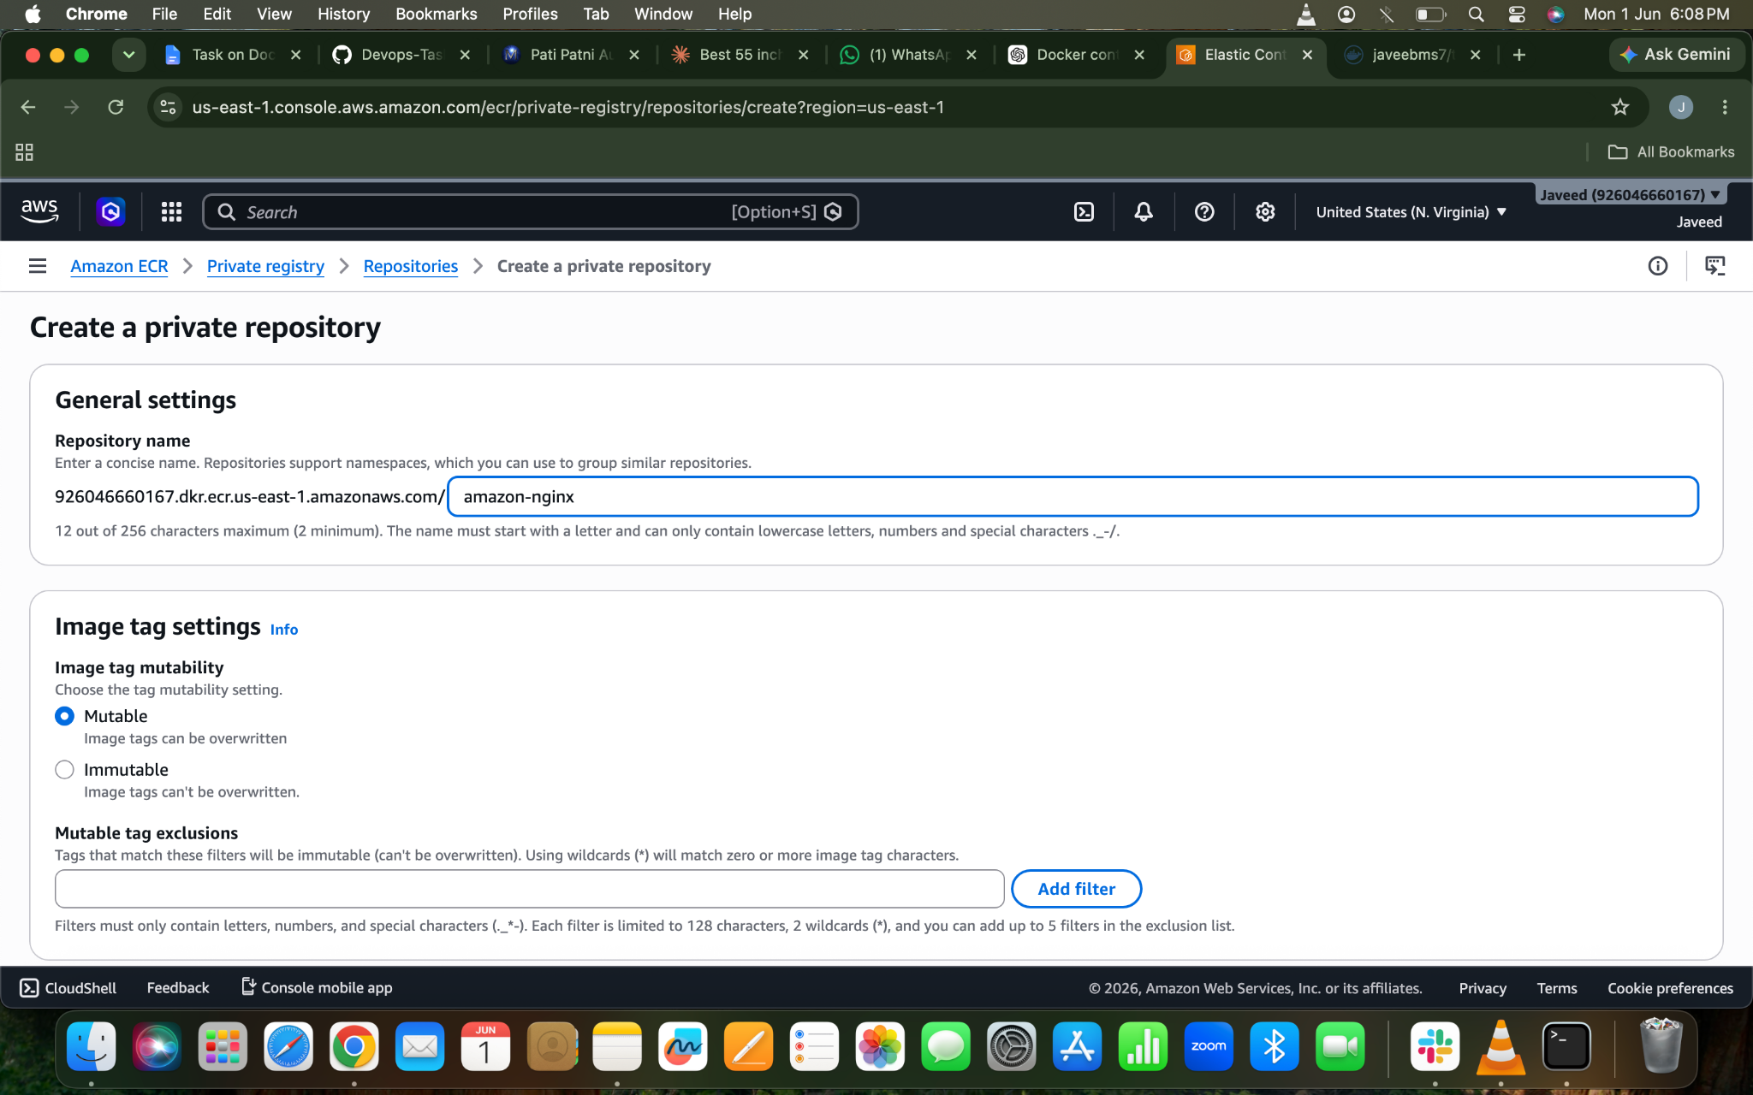
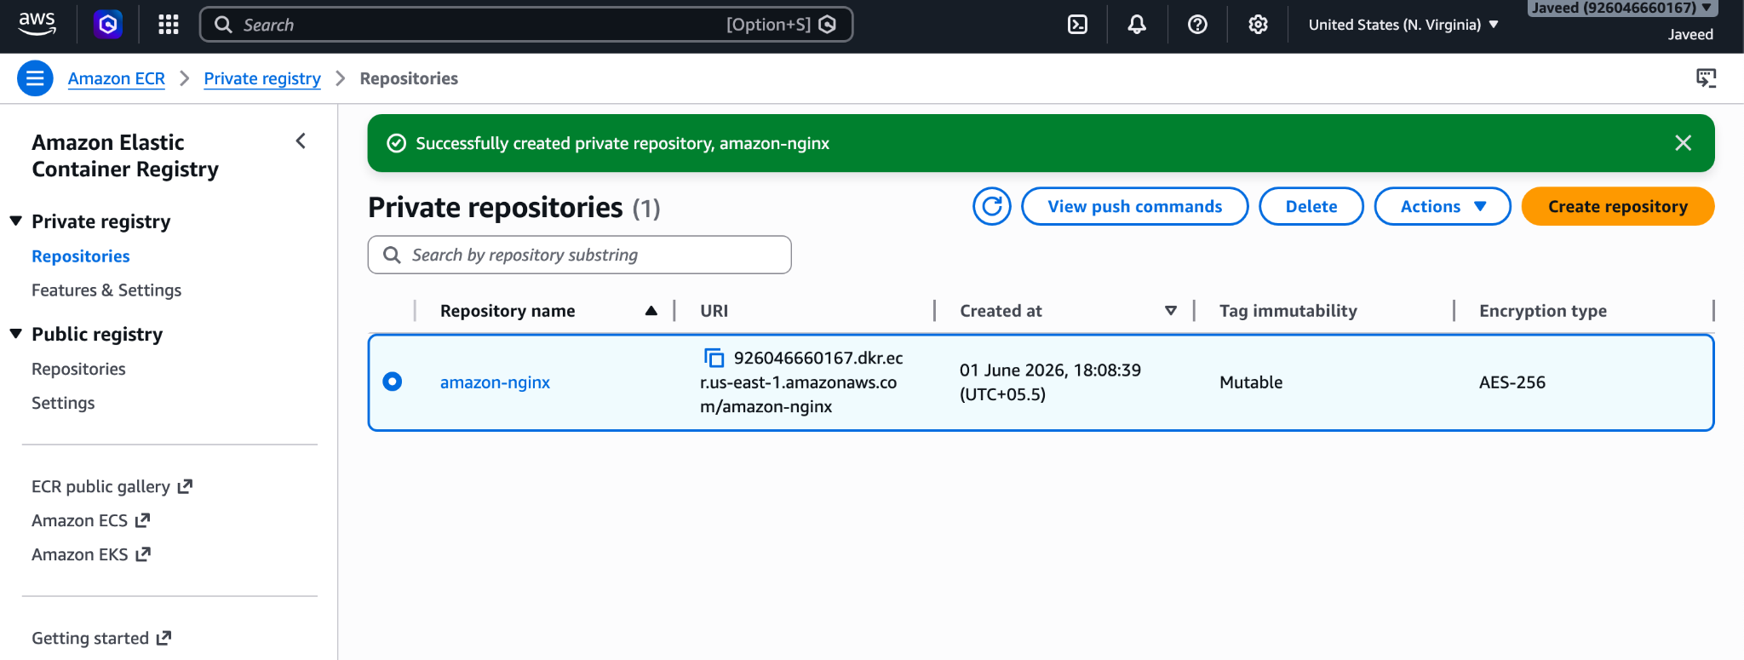
Install AWS CLI using command
apt install awscli -y
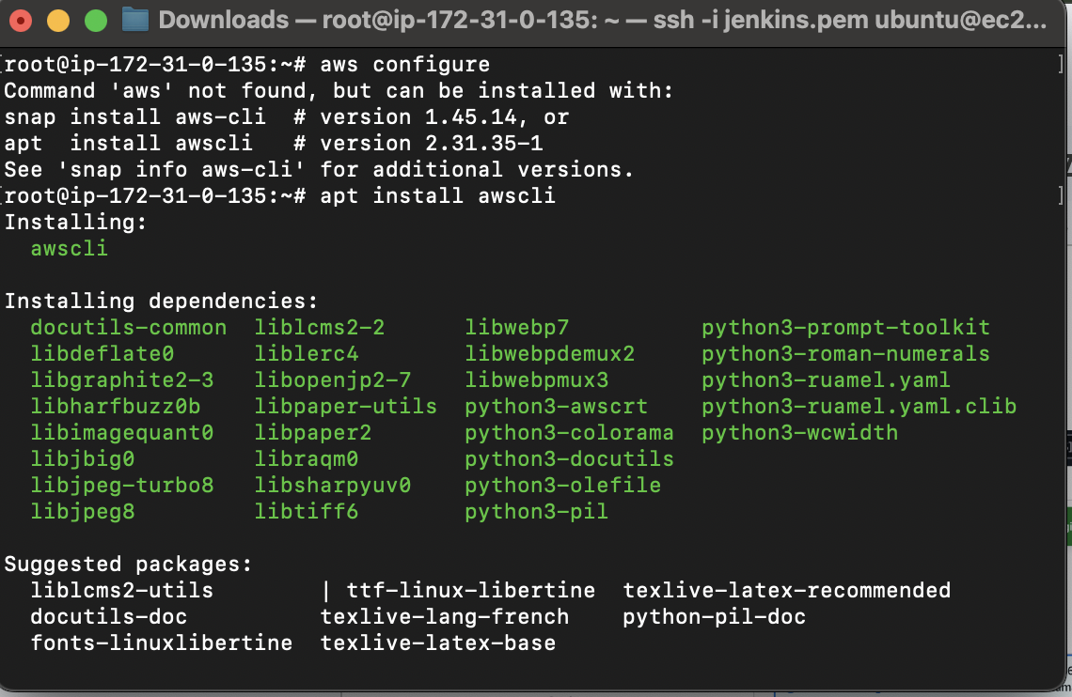
Aws configure
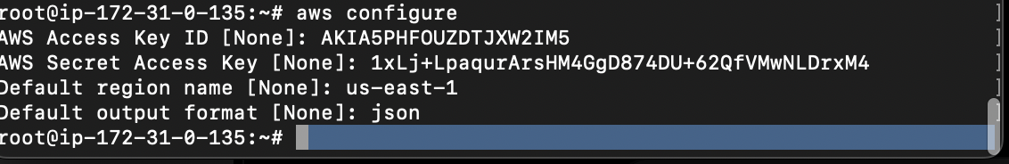
Login using the below command
aws ecr get-login-password --region us-east-1 | \
docker login \
--username AWS \
--password-stdin 926046660167.dkr.ecr.us-east-1.amazonaws.com/amazon-nginx ⇒u will get this from the URI in the below image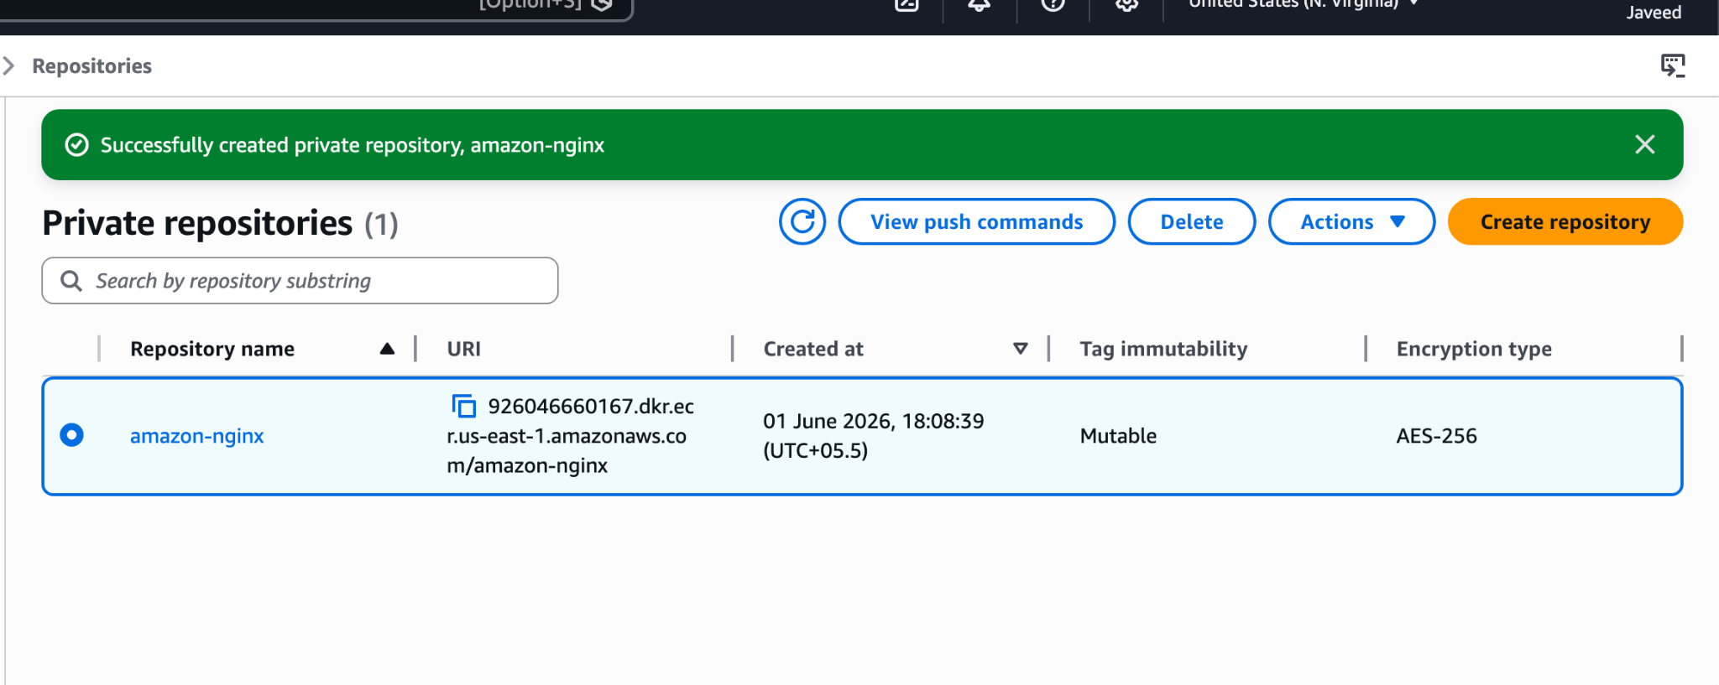

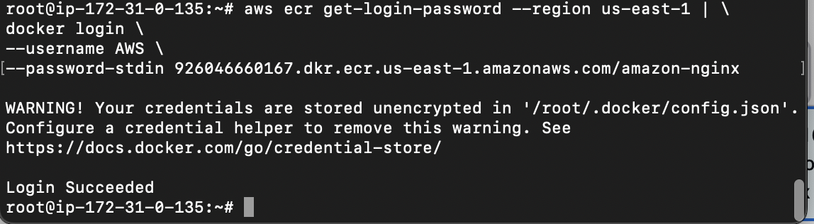
Now lets rename our image to repo name by using command
docker tag javed:v1 926046660167.dkr.ecr.us-east-1.amazonaws.com/amazon-nginx:v1

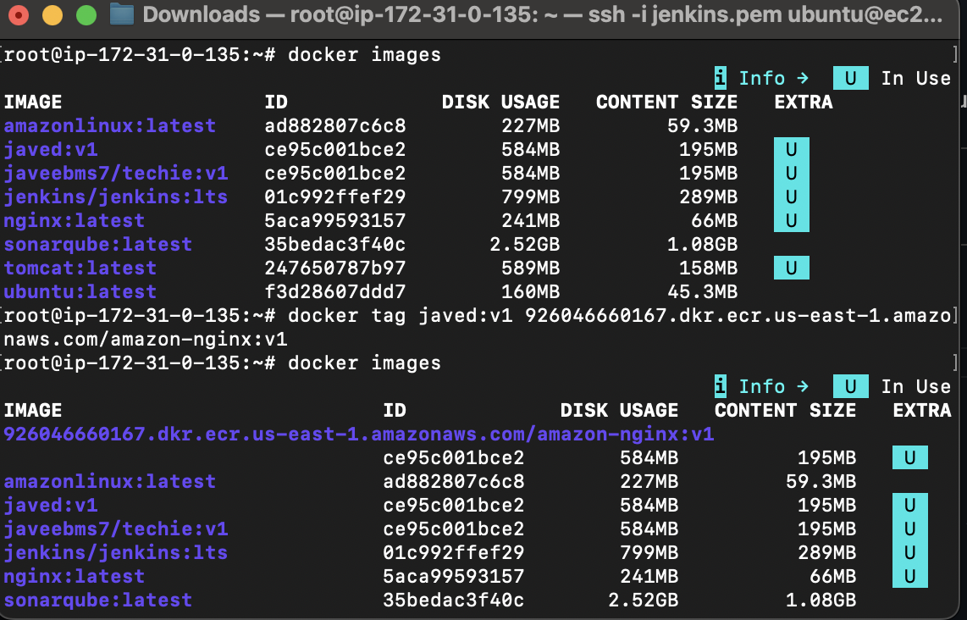
Now lets push to our ECR repo by using command
docker push 926046660167.dkr.ecr.us-east-1.amazonaws.com/amazon-nginx:v1
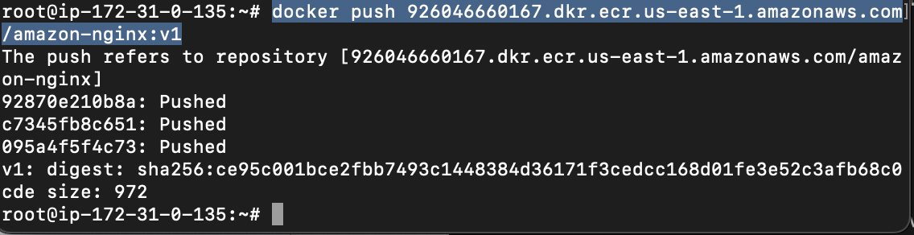
Lets check in the AWS ECR
It has been pushed successfully
